Instructions for the provider when MA has initiated the video call with the patient.

- Click Unmute and Start Video to start visit with the patient.

- Verify patient using two identifications (name & DOB).
- Click End Meeting.

- Click End Meeting for All.
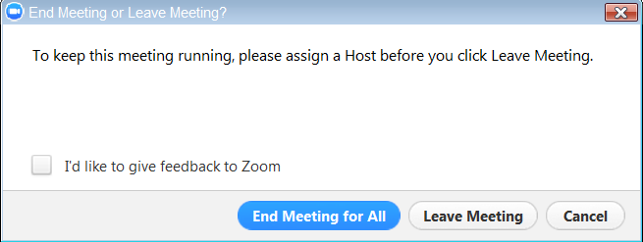

Instructions for when the provider initiates the video call with the patient.

- Double click the Zoom icon on the desktop.
- Click Sign in.
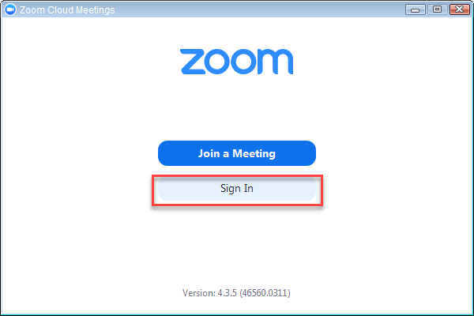
- Enter your site’s log-in information.
  - Username: Email address
  - Password:
- Click Sign In.
- Click Meetings.

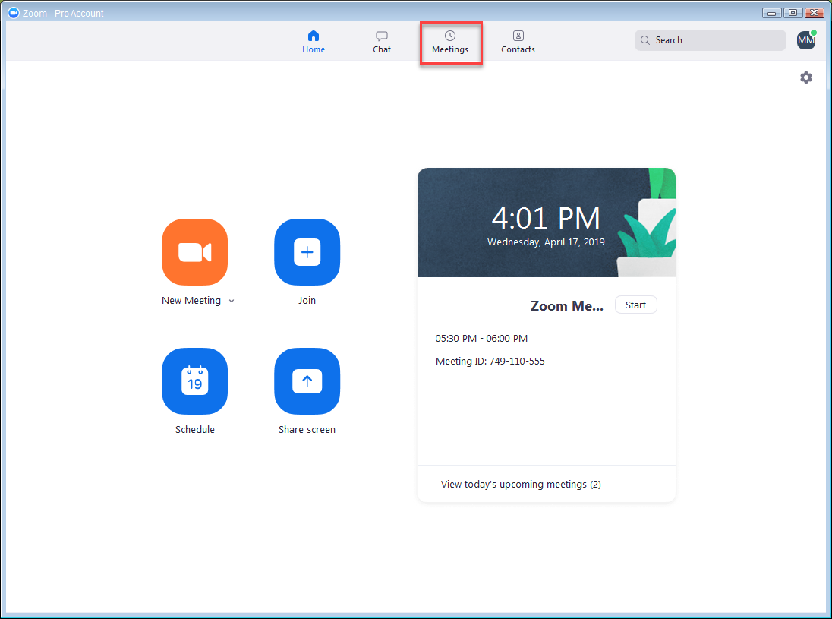

- Find appropriate patient, date and time. Click Start.
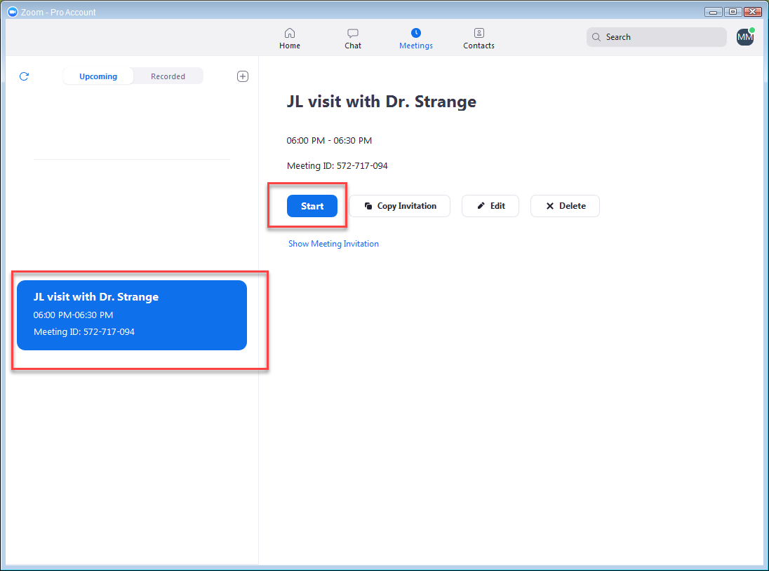

- Click Join Audio Conference by Computer.
- When the patient joins the meeting in zoom, click Admit.
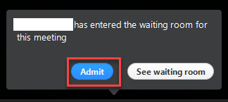
- Verify patient using two identifications (name & DOB).
- Complete required elements in Epic per documentation requirements.
- Note: You can Mute and Stop Video as needed using the icons below.

